SKY B Trans
Dashboard:
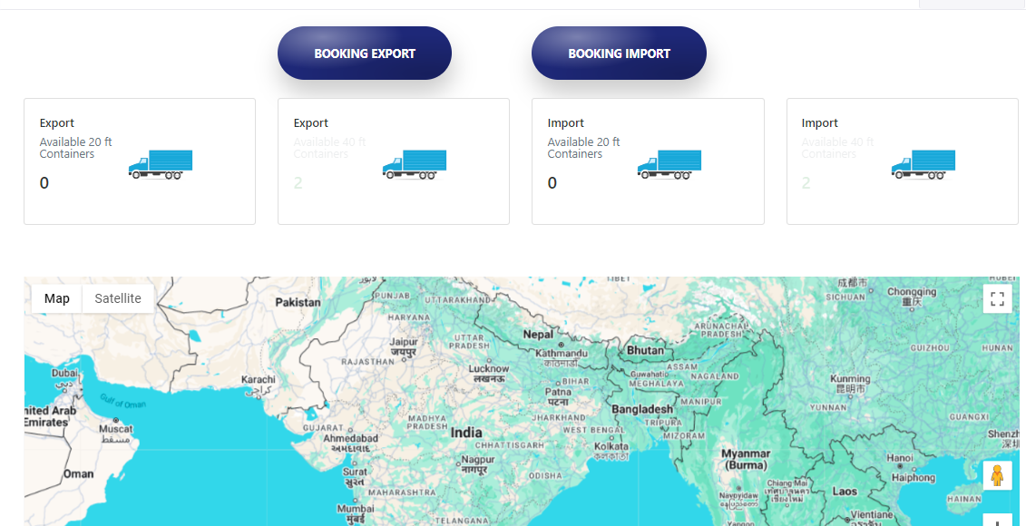
1.Change the truck to face the right side

Users:
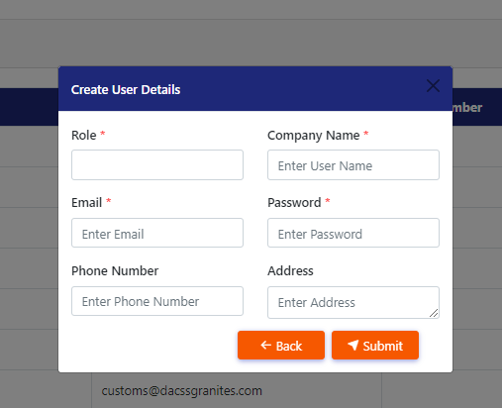
- Phone number- mandatory
- Role select option
- Add Status option- Active, Inactive
- Add Description

Client Information:
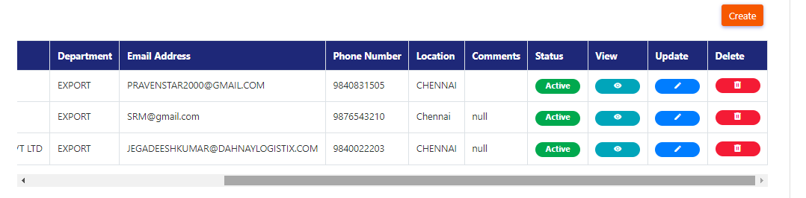
- Remove Comments from grid
- Add GST number
- Add Location (city, State)
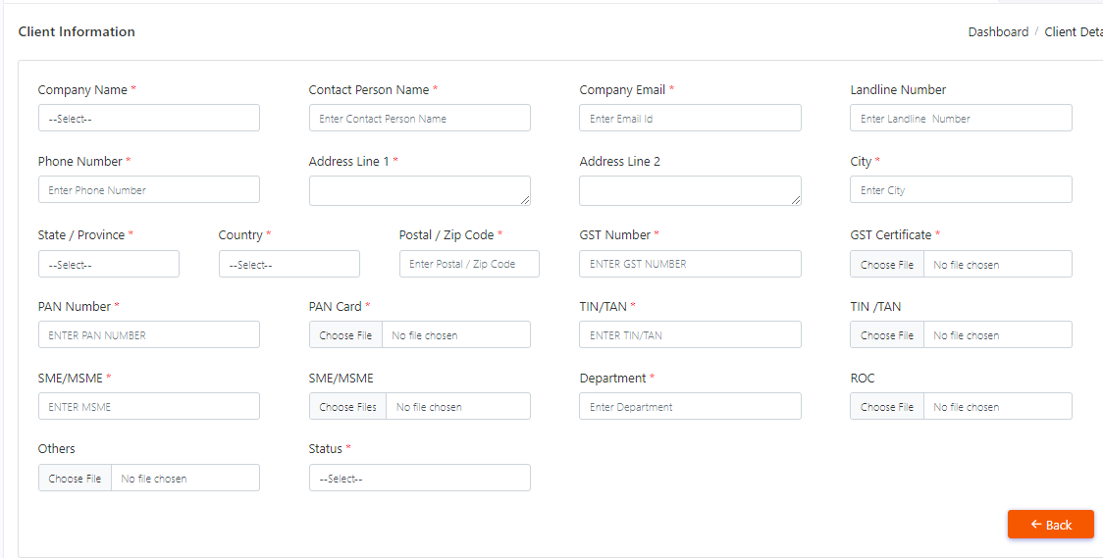
- Add Basic information (below company name to Postal code)
- Change the company name dropdown into a text field
- Add Nature of business (Manufacturer, Traders, Shipping line, Freight Forwarding, Warehousters)
- Add Document Details
- Change the Other file upload to allow multiple file uploads.
- Change the status option to a radio button
- Add client bank details
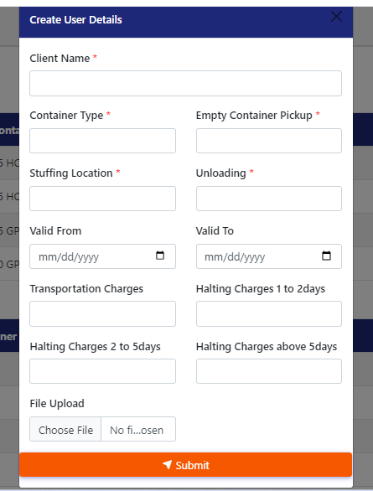
- Change unloading into Unloading Location
- Change File upload into Agreement
- Change the file upload to allow multiple file uploads.
- Dropdown - Import , Export
- Add Stuffing Location 2.
- Change header- create User details to create Client price details.
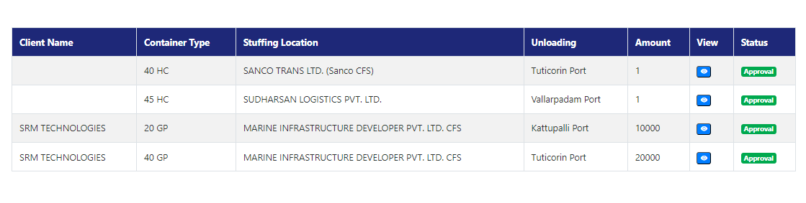
- Add Date validation (Valid From - Valid To)
Vendor Information: Company Details
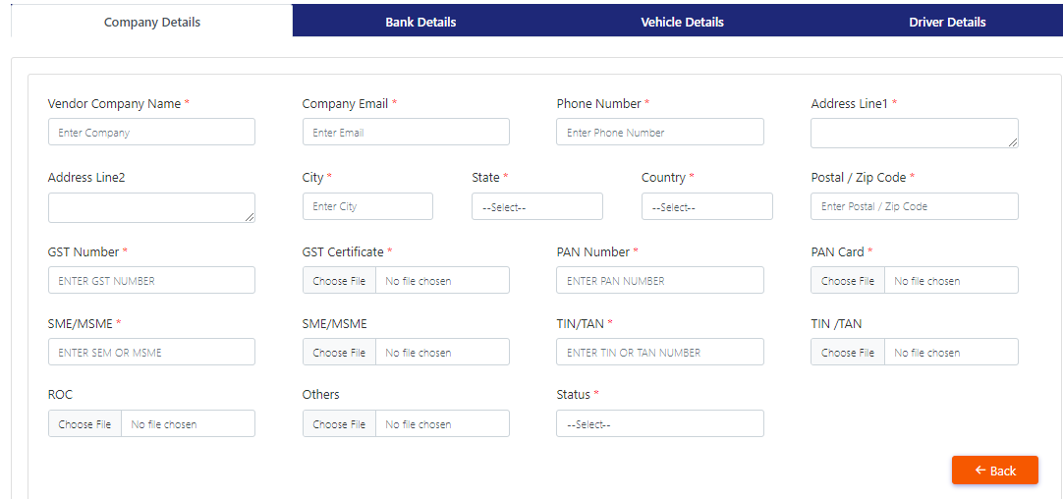
- Change Vendor Company name into Company name
- Add Basic information(Below Company name to Postal code)
- Add Document Details
- Change the Other file upload to allow multiple file uploads.

Bank Details:
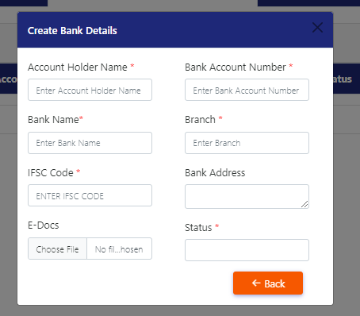
- Change Bank Account number into Account number
- Change Bank Name into Name of the Bank
- Change the E-docs file upload to allow multiple file uploads.

Vehicles Details:
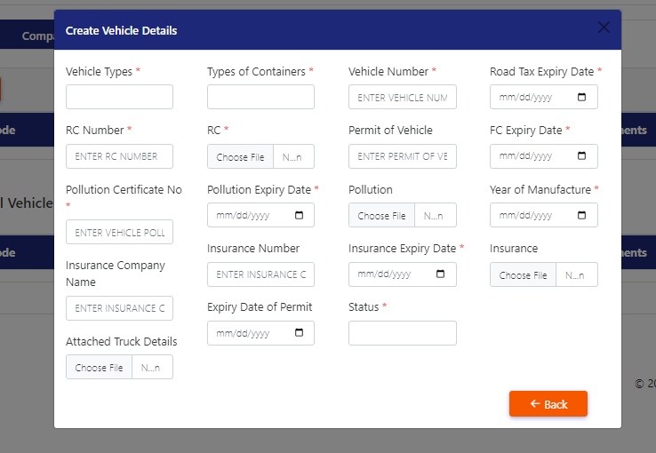
- Remove s from Vehicle Type(s)
- Change types of containers to container type
- Remove permit of vehicle
- Add Permit Validity (date option)
- Change the Attached Truck Details file upload to allow multiple file uploads.

Driver Details:
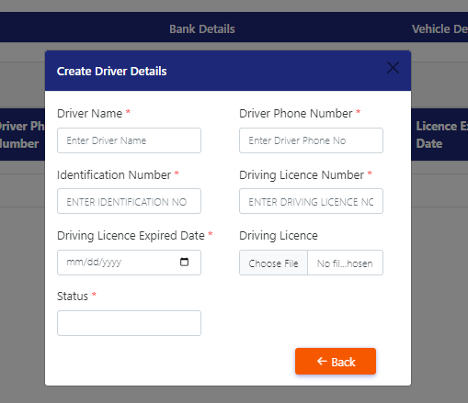
- Remove mandatory from Identification number.
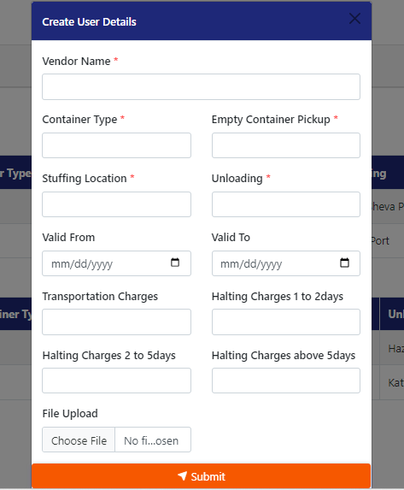
- Change unloading into Unloading Location
- Change File upload into Agreement
- Change the file upload to allow multiple file uploads.
- Dropdown - Import , Export
- Add Stuffing Location 2
- Change header- create User details to create vendor price details.

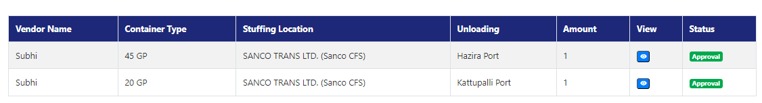
- Add Date validation (Valid From - Valid To)
Booking: Export
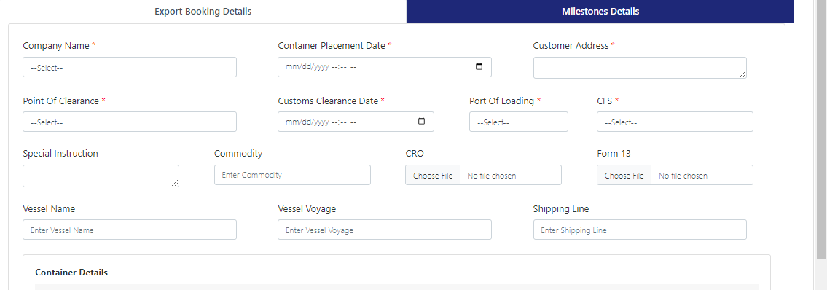
- Change Company name to Customer Name
- Company address to Pickup address
- Point of clearance to Place of clearance
- Add Phone number, Contact person name
- Change flow – Shipping Line > Vessel Name>Voyage number
- Add Port cutoff (date & time)
- Add ETD (date & time)
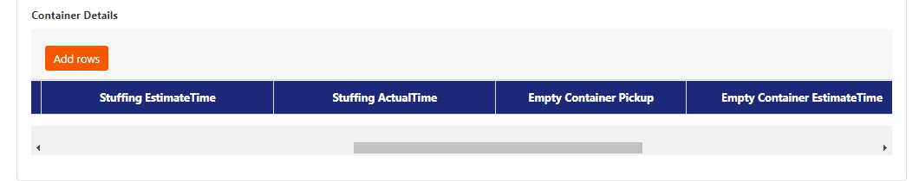
- Flow- weight Type> cargo type
- Remove Estimate and Actual Time from add row
Booking: Import
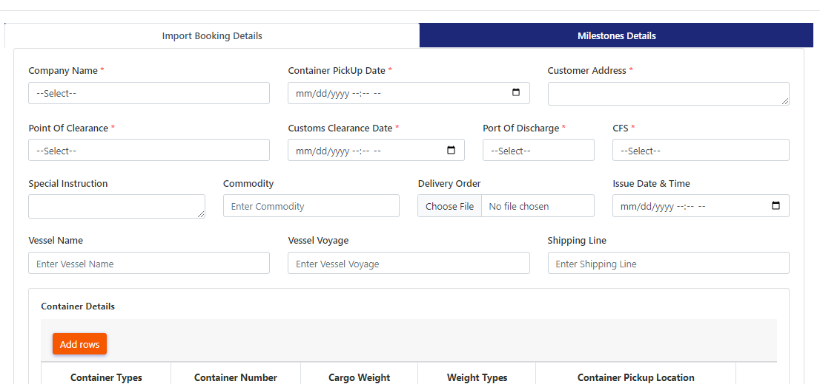
- Change company name into Customer name
- Change Customer address into Delivery address
- Change Point of clearance to Place of clearance
- Change Issue date & time into DO Issue date
- Add DO valid upto (Date)
- Change flow – Shipping Line > Vessel Name>Voyage number
- Add ETA (date & time)
- Add Phone number, Contact person name

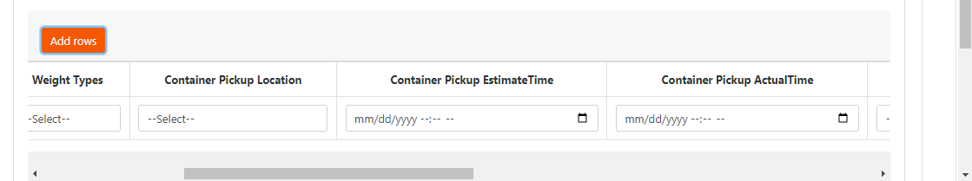
7.Remove Estimate and Actual Time from add row
8. Flow- weight Type> cargo type

Invoices:
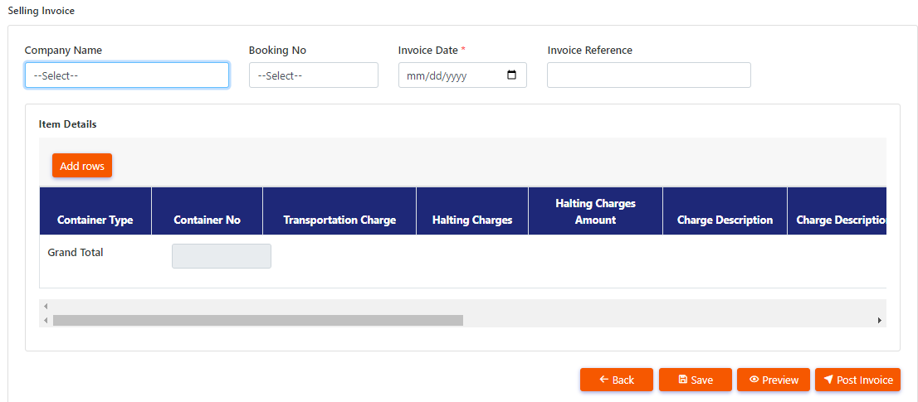
- Invoice date- Do not show future dates.
- Pdf- remove pan
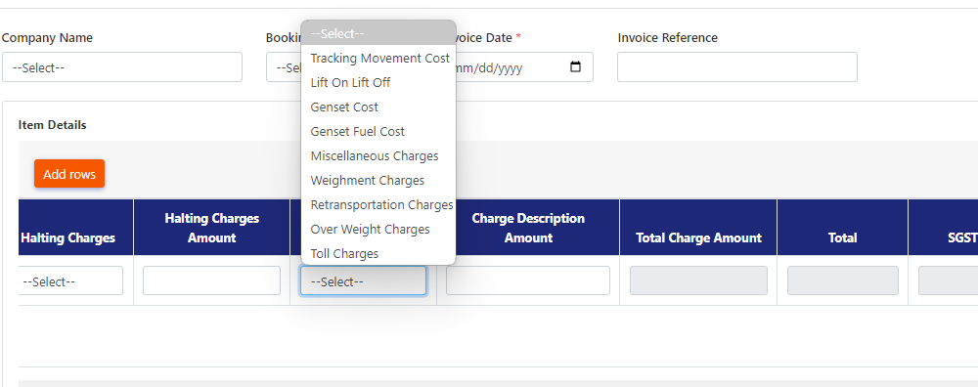
- Charge description dropdown- Tracking movement cost into Transportation Charges
- Retransportation charges into Re-Transportation charges

